**Data Structures.** Assignment #7

Course: CSE22101

Name: Dauren Abdykaparov

Student ID: 20142001

6.5.2

A)

|  |  |  |  |  |  |  |  |  |  |  |
| --- | --- | --- | --- | --- | --- | --- | --- | --- | --- | --- |
|  | 0 | 1 | 2 | 3 | 4 | 5 | 6 | 7 | 8 | 9 |
| Ee | 0 | 5 | 6 | 12 | 15 | 16 | 16 | 19 | 21 | 23 |
| Le | 0 | 9 | 6 | 12 | 15 | 19 | 16 | 19 | 21 | 23 |

|  |  |  |  |  |  |  |  |  |  |  |  |  |  |  |
| --- | --- | --- | --- | --- | --- | --- | --- | --- | --- | --- | --- | --- | --- | --- |
|  | <0,1> | <0,2> | <1,3> | <2,3> | <2,4> | <3,4> | <3,5> | <3,6> | <4,6> | <4,7> | <5,9> | <6,8> | <7,8> | <8,9> |
| E | 0 | 0 | 5 | 6 | 6 | 12 | 12 | 12 | 15 | 15 | 16 | 16 | 19 | 21 |
| L | 0 | 0 | 9 | 6 | 12 | 12 | 15 | 12 | 15 | 15 | 19 | 16 | 19 | 21 |

B) 23

C) <0,1>, <0,2>, <2,3>, <3,4>, <3,6>, <4,6>, <4,7>, <6,8>, <7,8>, <8,9>

D) Yes. E.g., speeding-up <8,9> activity from 2 to 1 will result in project length decreased by one.

7.3.1

[12 2 16 30 8 28 4 10 20 6 18] | 0 10

[4 2 6 10 8] 12 28 30 20 16 18 | 0 4

2 4 [6 10 8] 12 28 30 20 16 18 | 2 4

2 4 6 [10 8] 12 28 30 20 16 18 | 3 4

2 4 6 8 10 12 [28 30 20 16 18] | 6 10

2 4 6 8 10 12 [16 18 20] 28 30 | 6 8

2 4 6 8 10 12 16 [18 20] 28 30 | 7 8

7.5.1

12 2 16 30 8 28 4 10 20 6 18

2 12 16 30 4 8 10 28 6 18 20

2 4 6 8 10 12 16 18 20 28 30

7.7.1

12 2 16 30 8 28 4 10 20 6 18

30 10 20 12 2 4 16 6 8 28 18

2 4 6 8 10 12 16 18 20 28 30

5

H(123) = 123 % 11 = 2

H(42) = 42 % 11 = 9

H(13) = 13 % 11 = 2 -> busy -> try +1, +4, +9, +16 … -> 2+1=3 is free -> 3

H(17) = 17 % 11 = 6

H(22) = 22 % 11 = 0

H(37) = 37 % 11 = 4

|  |  |  |  |  |  |  |  |  |  |  |
| --- | --- | --- | --- | --- | --- | --- | --- | --- | --- | --- |
| 0 | 1 | 2 | 3 | 4 | 5 | 6 | 7 | 8 | 9 | 10 |
| 22 |  | 123 | 13 | 37 |  | 17 |  |  | 42 |  |

9.2.3

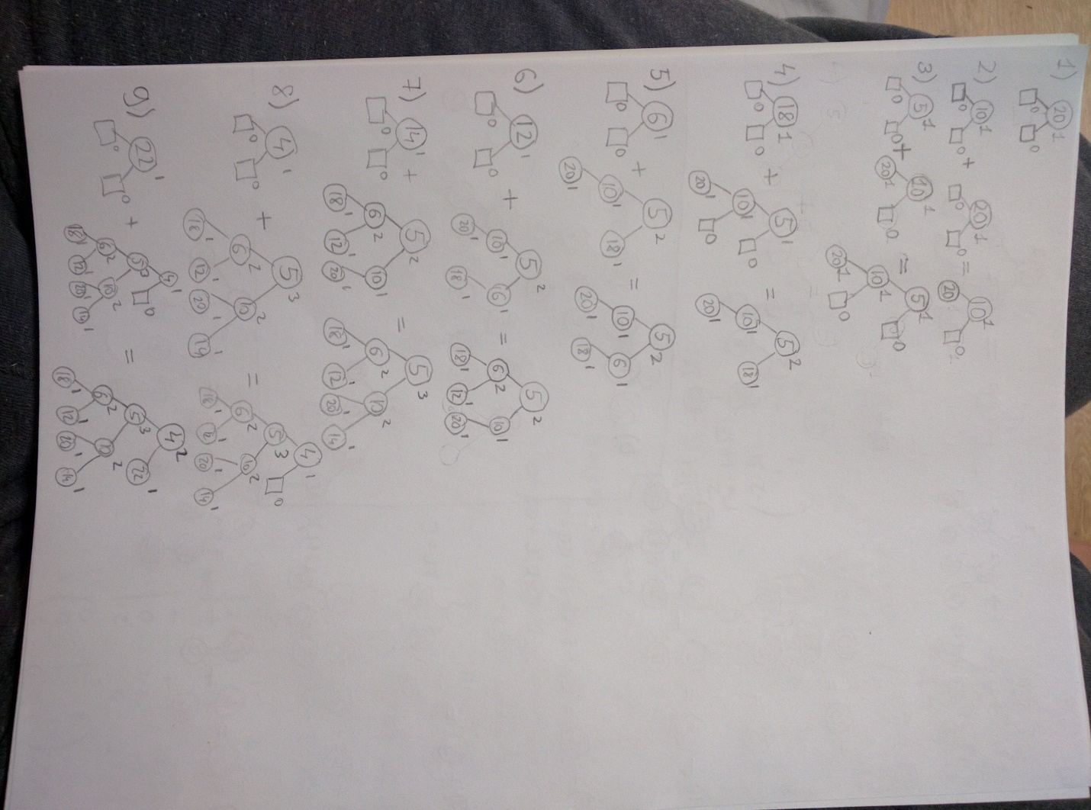

9.2.3.b.

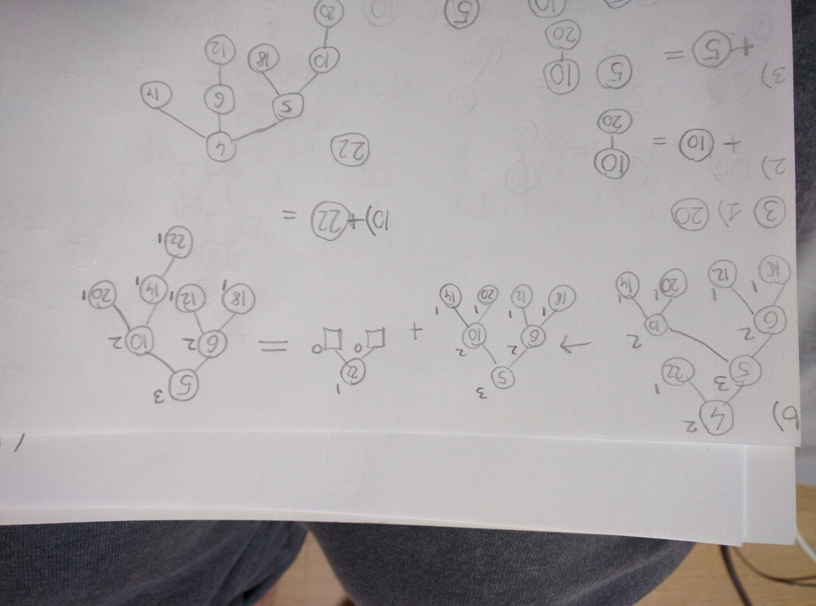

9.3.3.

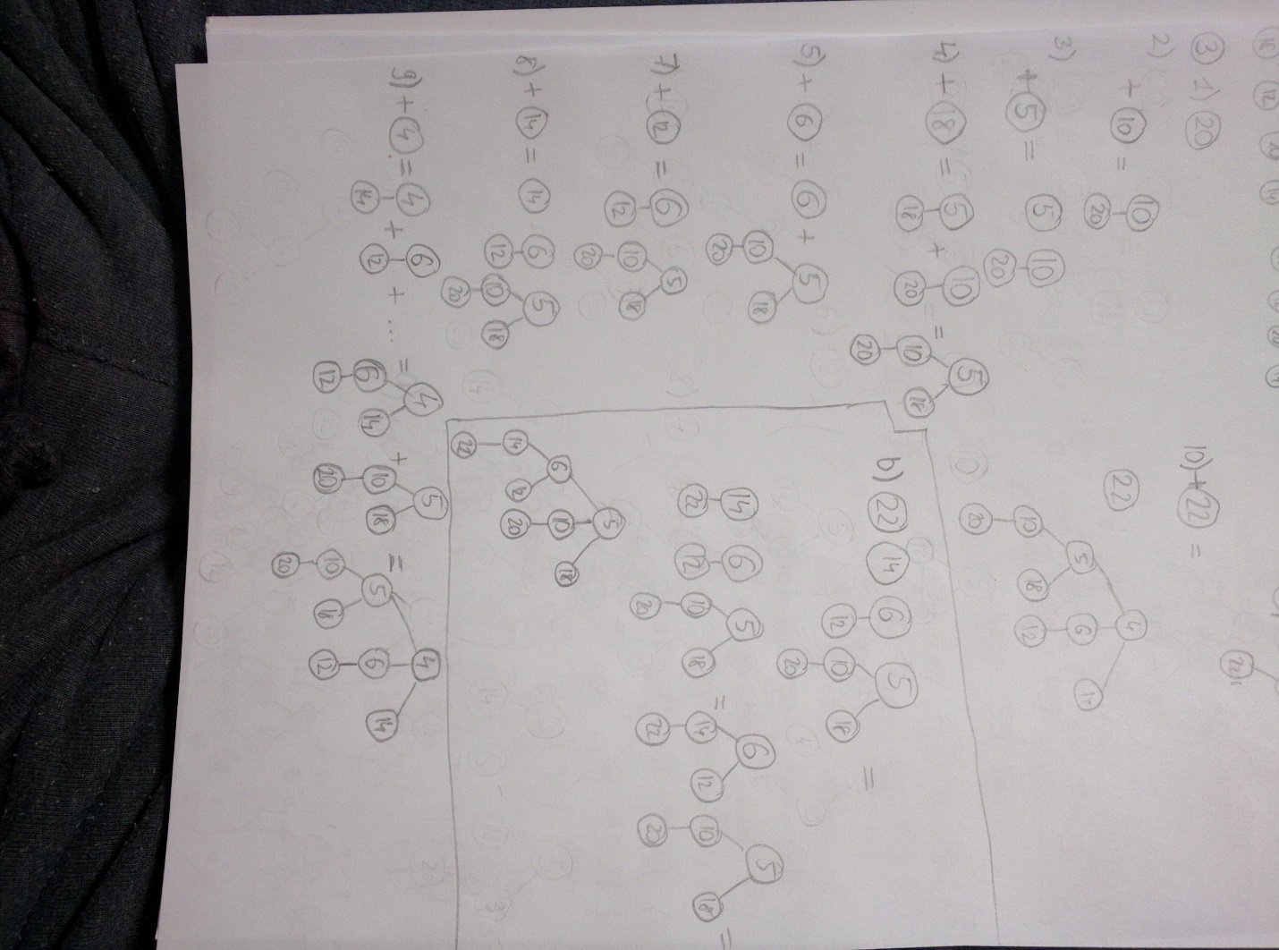

9.4.7.

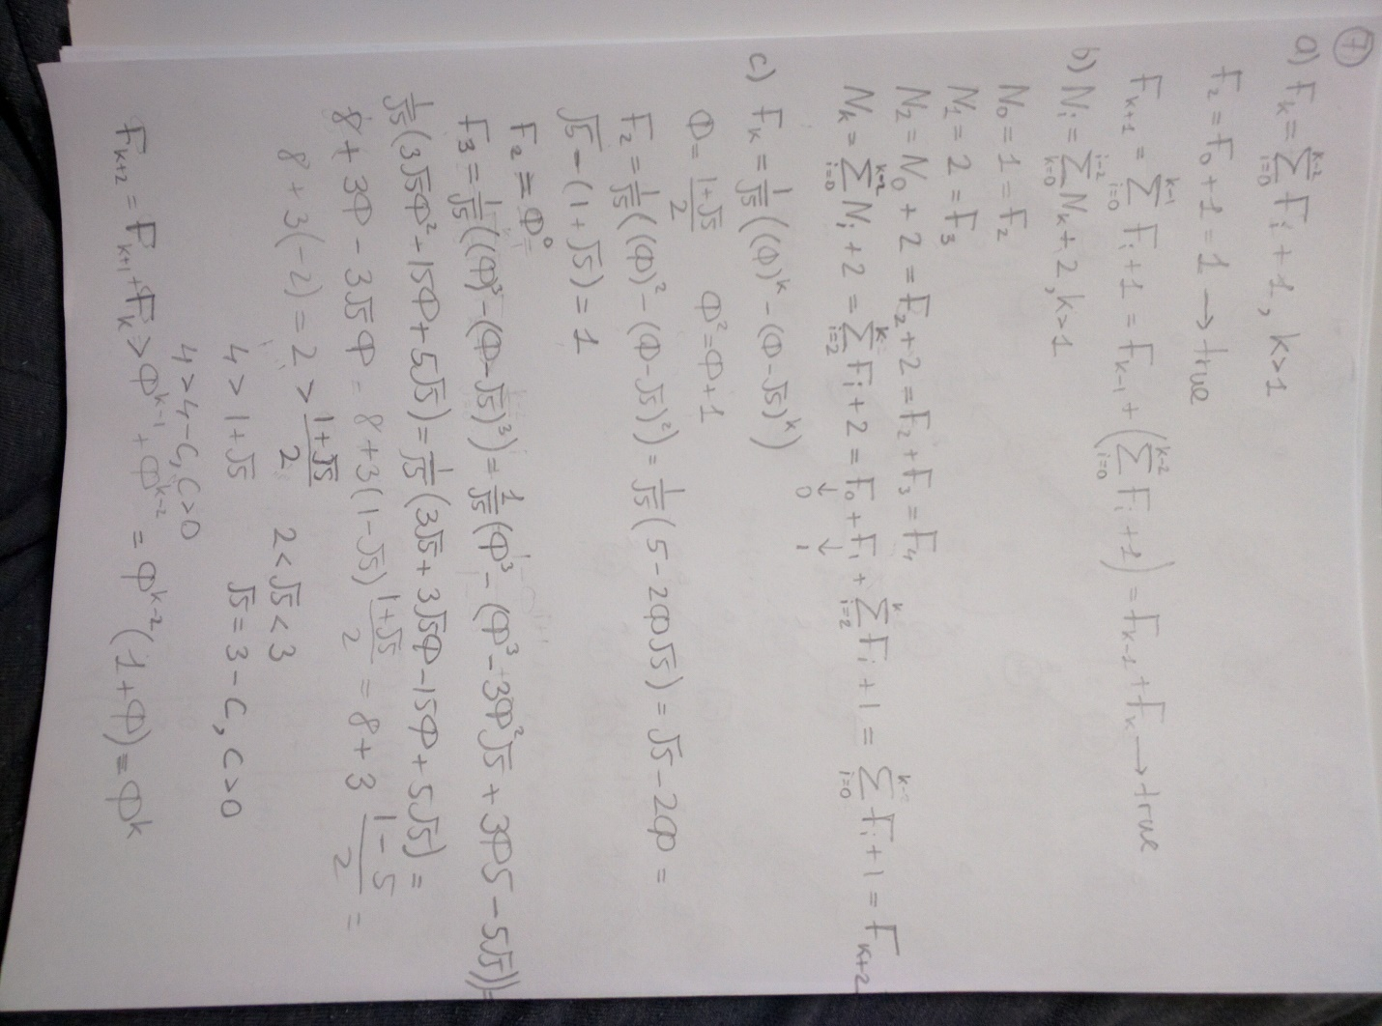

9 & 10

